Bernard Turner

Derrick Worsley

Mobile Application Development COM-437-OL01

5/13/2022

Wireframing

**Log-In Page**

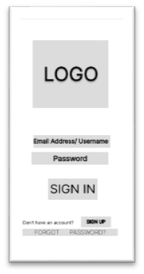

**Registration Page**

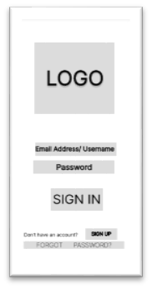

**Main Page**

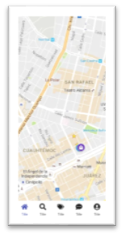

**Chat**

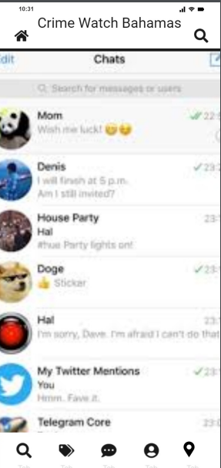

**User Profile**

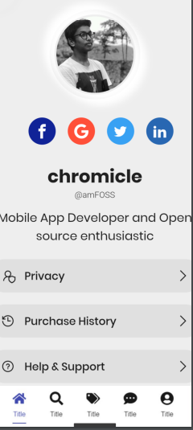

**Notifications**

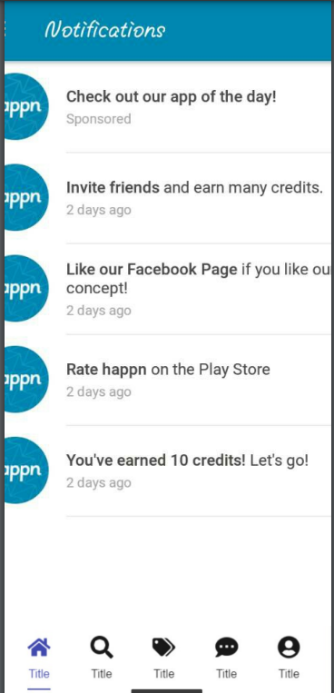

**Report Crime**

